GREENING YOUR PERSONAL AND HOUSEHOLD LIFE

We have a God given mandate to care for all people and all creatures and all plants. This is stewardship. This is love.

BUY LESS STUFF – BUY USED – RE-CYCLE – REPAIR -REUSE

Everybody needs energy. But how you obtain energy and how you spend that energy are the keys to developing a greener world.

How to start
- Educate yourself
  - Drawdone.org – best general web site about climate change and our response to it
  - EPA.gov>greener-living;
  - Episcopal Diocese of California: www.diocal.org/resources/eco-justice
- Advocate locally, state and regionally and nationally
- Communicate with family, neighbors, friends. Share ideas

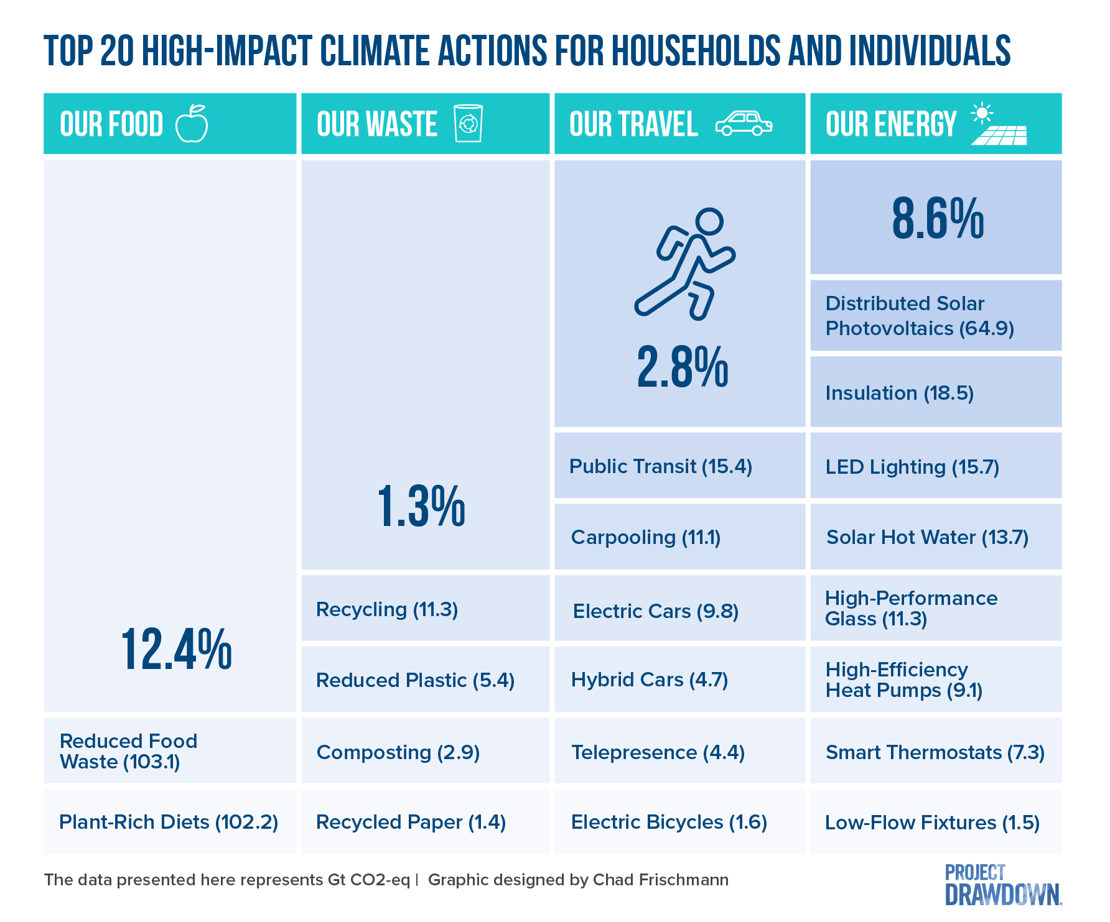

Food Industrial farming damages the ecosystem through waste and pollution and severe deterioration of the soil and biodiversity. It is responsible for ~ 25% of emissions. Reducing food waste saves emissions at all levels of food production
- Eat low on the food chain: fruits, vegetables, grains and beans
- Eat less meat particularly beef
  - Industrial raised animals CO2 Equivalent Emissions Kg/1000 kcal: Beef 37, Lamb 12, Pork 5
  - Use ground turkey or pork instead of ground beef
  - Use a local butcher using local farmers with pastured raised animals
- The more you eat locally, the less transportation of food is involved with its incumbent greenhouse gas emission and excess packing
  - Use a CSA – Community Supported Agriculture
  - Shop at Farmers Markets
  - Grow your own vegetables – consider a community garden

Housing
- Install Solar Panels – some communities will help with financing this project
- Weatherization: windows, doors, insulation of walls, ducts, pipes and attic
- Change incandescent light bulbs to LED bulbs.
- Switch off lights and unplug electric devices when not in use
- Use smart power strips to reduce electrical use of devices on standby
- Invest in a Smart Thermostat
- Consider a whole house fan in the summer to minimize AC
- Turn water heater down to 120F
- Use low flow faucets and shower heads
- Buy energy efficient appliances
- Assess your fireplace which can be a big loss of heat and be polluting. Consider glass doors, inserts and use of gas. Catalytic features with a wood burning insert can almost eliminate polluting smoke
- Use non-toxic household cleaning materials

Transportation
- Walk or bike when possible – Consider adult tricycles and e-bikes
Walking 1 mile takes about 20 minutes and about 2000 steps
- Travel thoughtfully – combine errands, use public transportation, share rides
- Take care of your car i.e. tire inflation etc.
- Vacation locally. Wisconsin has great places to visit

Decreased Plastic/Paper
- Reusable shopping bags and produce bags
- Use both sides of paper and the back of envelops
- There are a large range of commercial products which replace plastic
  - Shampoo and conditioner bars
  - Non-plastic food storage bags
  - Bamboo paper goods i.e. toilet paper
  - Multiple products for laundry
- No paper towels/ facial tissue – ruse rags and hankies

